**SSIM based Classification**

**Claims from the Report**

**ESTIMATION OF PAIN LEVEL**

The concept of thresholding involves assigning certain numeric values to each template and while the sample is being compared to the template, it is correlated or rejected. Thus, this would specifically select the exact pain eve pf the infant (sample/ text image/ image in the cry condition).

Here, the correlation occurs based on structural similarity between the two images and the ranges of SSIM values have been set for various pain levels.

The relationship between the SSIM values and the pain level is as follows:

|  |  |
| --- | --- |
| **OBTAINED CORRELATION VALUE** | **PAIN LEVEL** |
| >0.85 | NO PAIN CONDITION |
| 0.7-0.85 | MILD PAIN |
| 0.4-0.7 | MODERATE PAIN |
| <0.4 | SEVERE PAIN |

**Results**

**Sample -1**

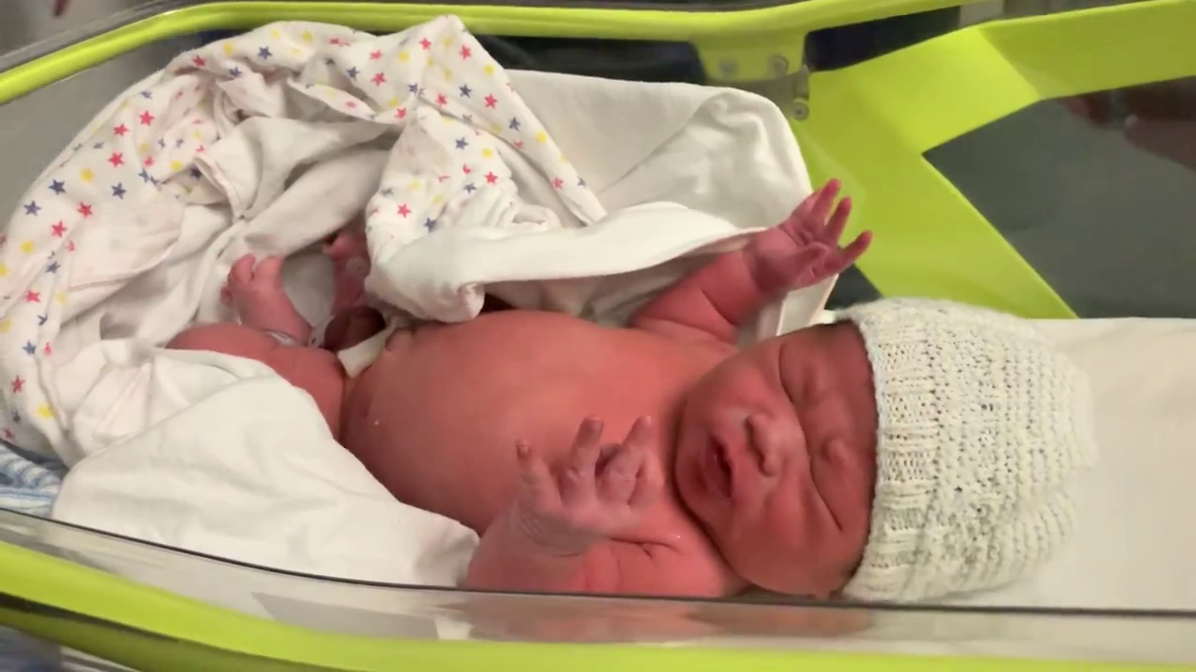 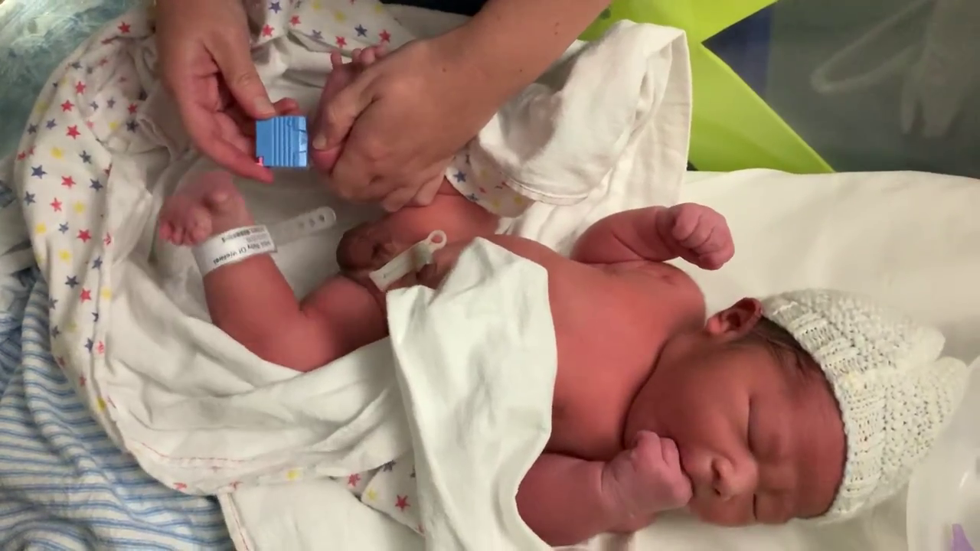

1. (b)

Fig 1(a) Reference Image (baby not crying) Fig 1(b) target image baby not crying

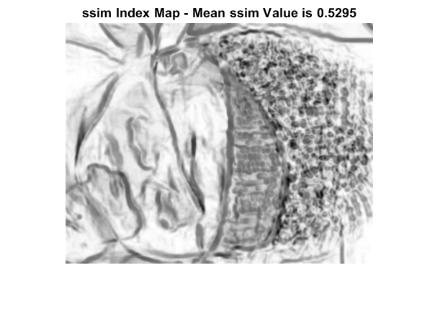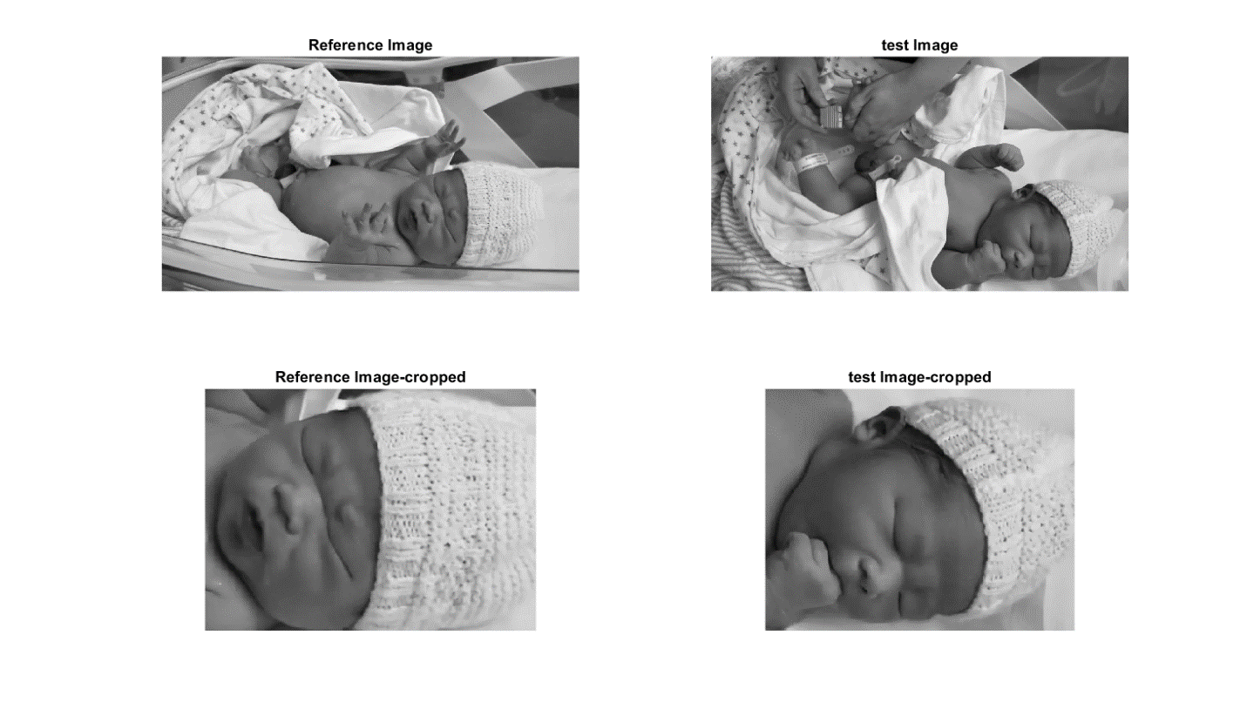

Matlab Output when the baby is sleeping

**Sample – 2**

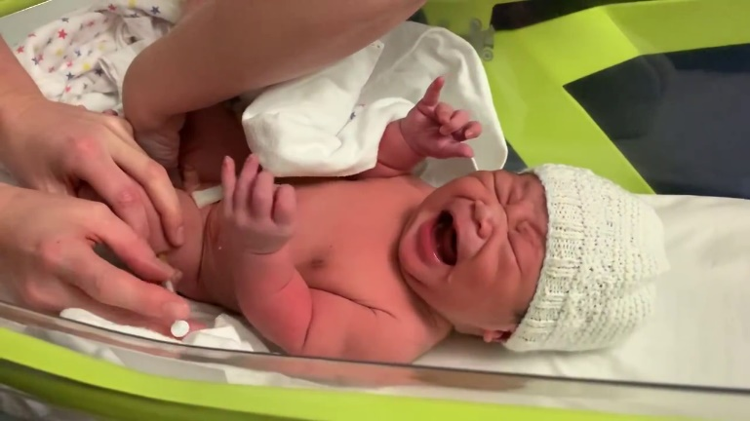 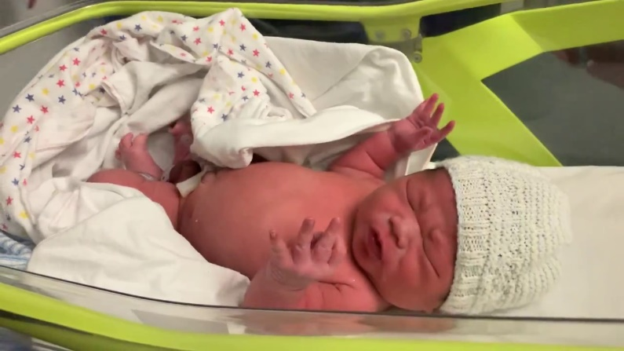

1. (b)

Fig 2(a) Reference Image (baby crying) Fig 2(b) target image baby not crying

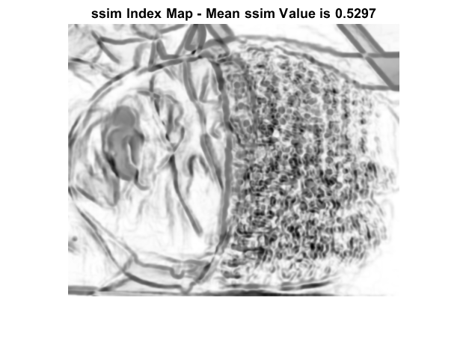

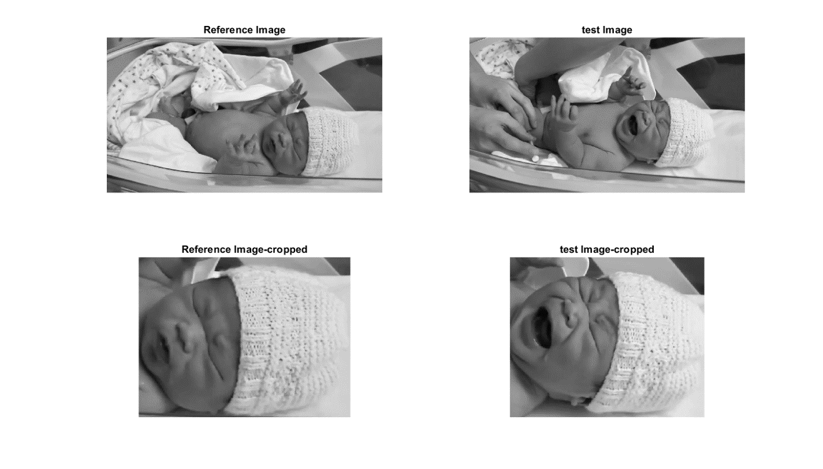

Matlab Output when the baby is given injection

**Sample -3**

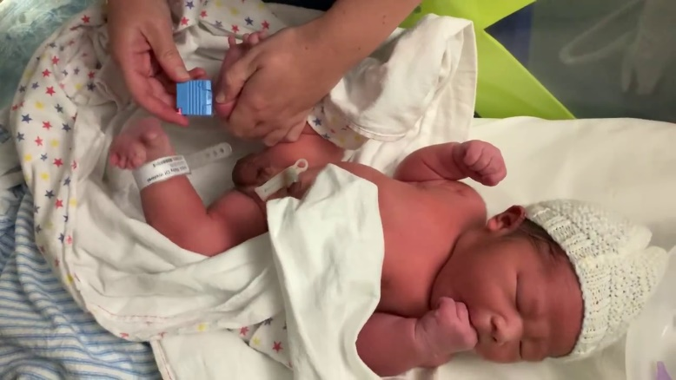 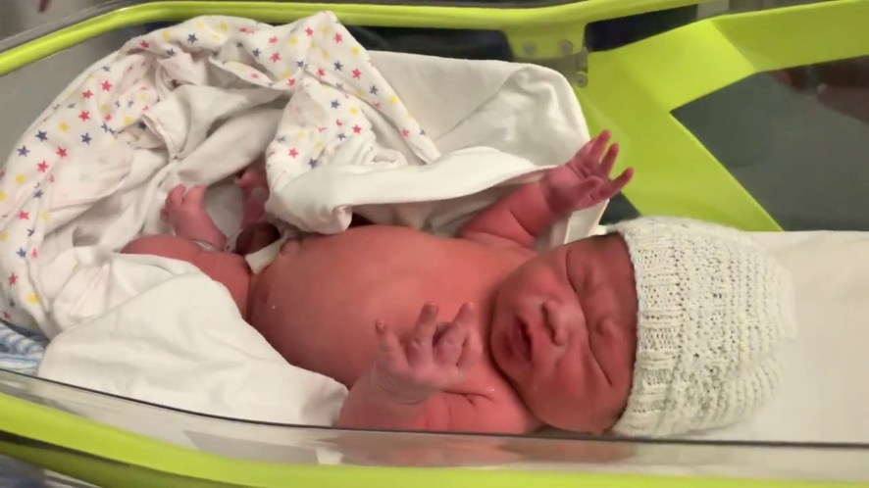

1. (b)

Fig 3(a) Reference Image (baby not crying) Fig 3(b) target image baby not crying

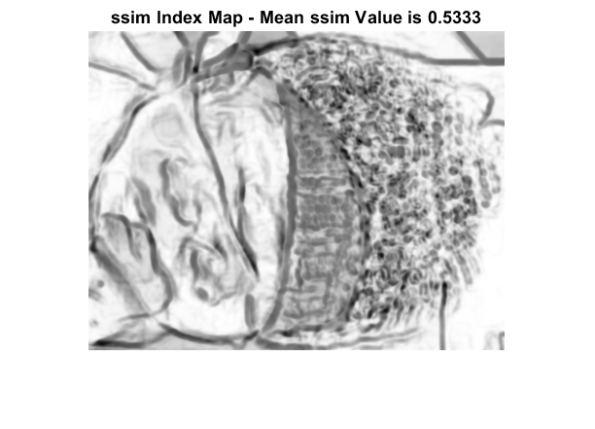

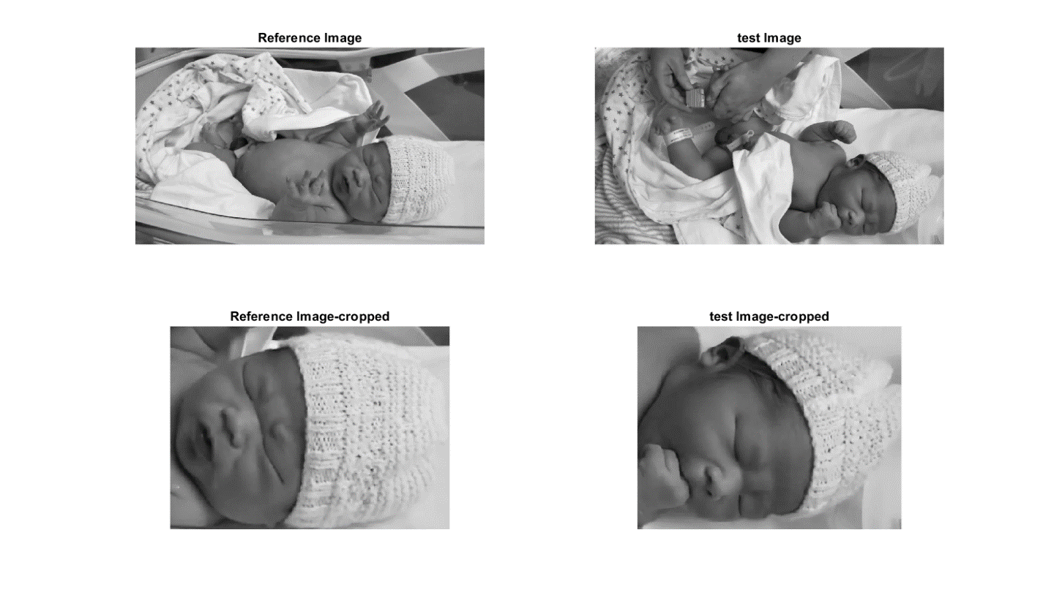

Matlab output when no cry

**Sample 4**

** **

1. (b)

Fig 3(a) Reference Image (Same image) Fig 3(b) target image (same Image)

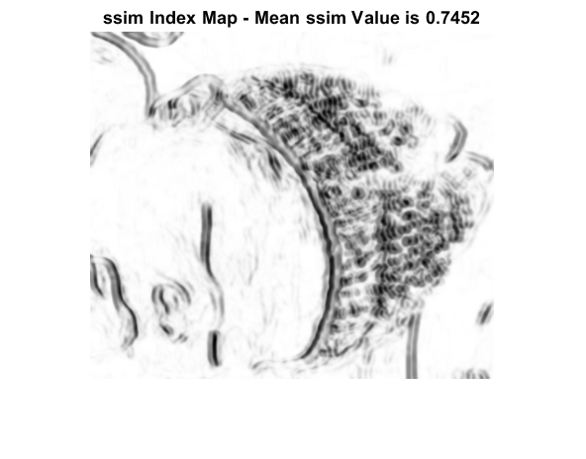

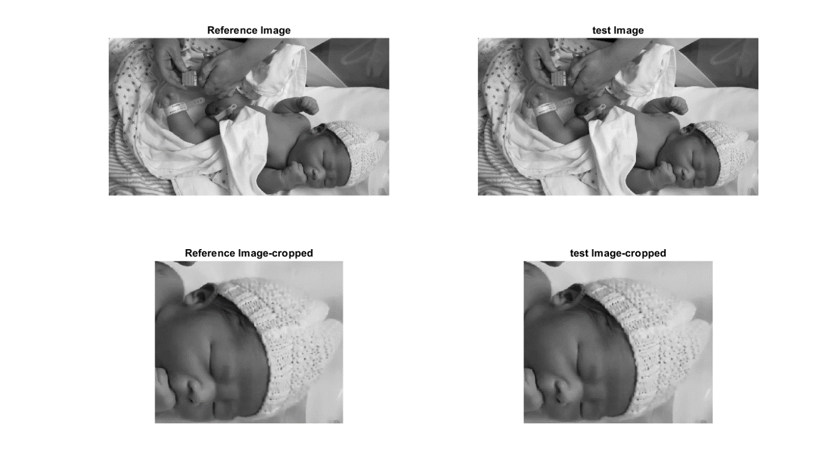

Matlab output when test image and reference image is same

**Observation**

* SSIM can only give the similarity between two images and cannot be used as a classifier as observed from sample 1-4
* SSIM can be used to detect motion changes in the frame as attached in the zip output
* The above claim may be valid if the baby is completely stationary, and the reference position doesn’t change while the facial expression may change
* The classification assumption is based on the distortion of the crying image from the original (reference frame) and doesn’t work for most of the video always resulting in similar range of value i.e. 5.01- 5.99
* Even when same image is fed with precise cropping accuracy the classification fails as shown in sample -4.
* MOTION DETECTION

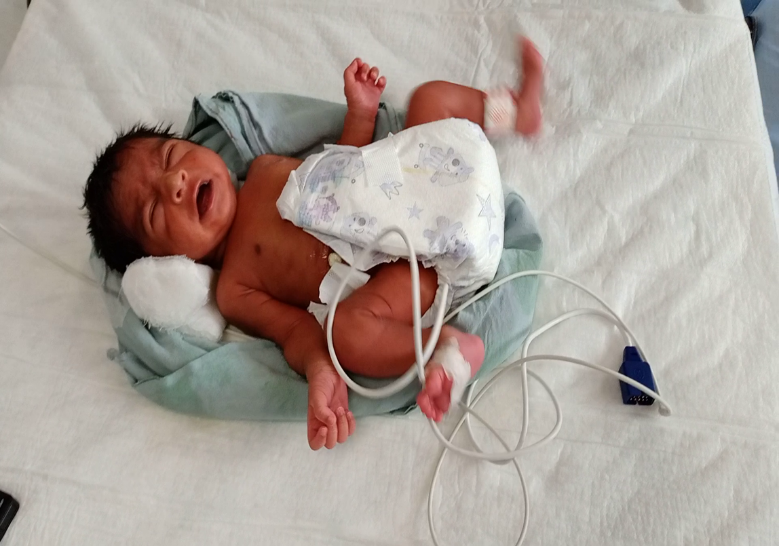

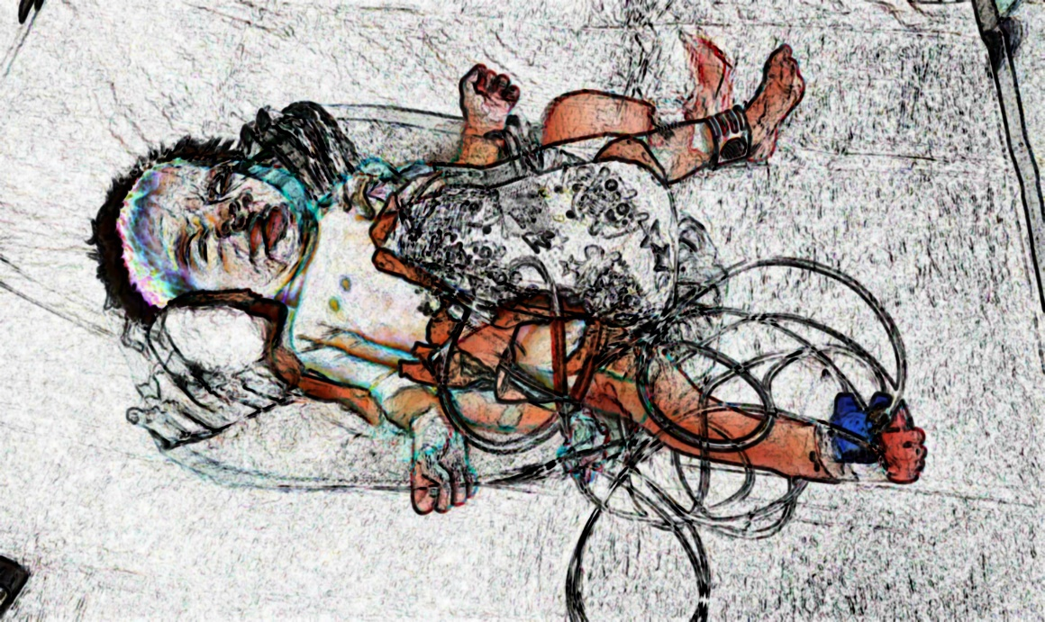

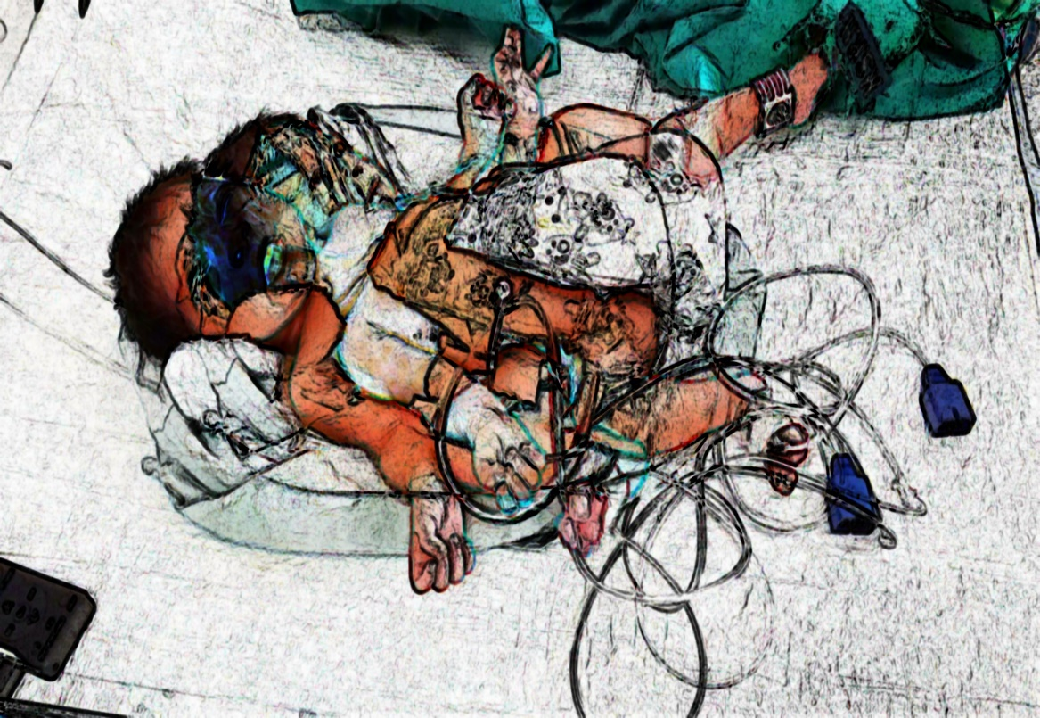

OPTICAL FLOW ALGORITHM

* Evaluates the difference between two images

